**SDLC**

**Software Engineering**

1. **What is SDLC?**

**-**  SDLC (Software Development Life Cycle) is a process in software engineering for planning, designing, coding, testing, deploying, and maintaining software.

1. **Write down the phases of Software Development Life Cycle.**

-

* **Communication:** The user requests the software and discusses needs with the developer.
* **Requirement Gathering:** The team collects all details about what the software should do.
* **Feasibility Study:** The team checks if the software can be made within budget, time, and technology.
* **System Analysis:** The team plans how the software will work and what resources are needed.
* **Software Design:** The team creates a blueprint (design) of how the software will look and function.
* **Coding:** Developers write the actual code to build the software.
* **Testing:** The software is checked for errors and fixed to ensure it works correctly.
* **Integration:** The software is connected with other systems or tools it needs to work with.
* **Implementation:** The software is installed and set up for the user to start using.
* **Operations & Maintenance:** The software is used, and updates or fixes are made as needed.
* **Disposition:** The software is retired or replaced when it becomes outdated.

1. **Differentiate between Functional & Non-Functional Requirements.**

**-** 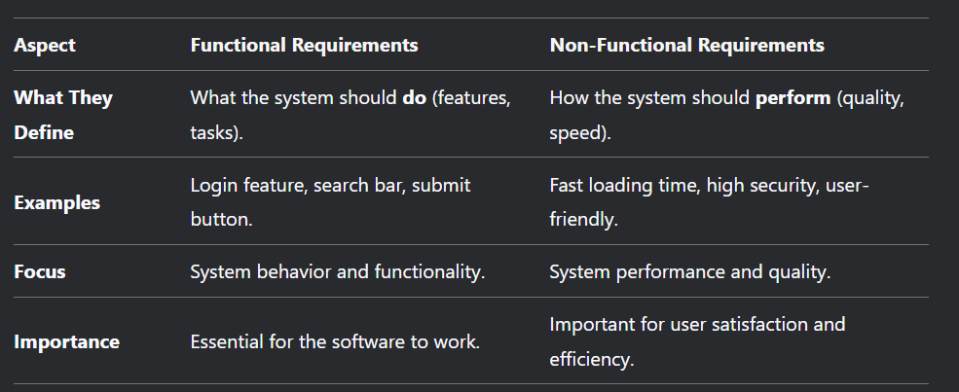

1. **How do developers gather requirements?**

- Developers gather requirements by:

* Studying existing systems,
* Interviewing users and developers,
* Conducting surveys, and
* Using questionnaires or databases.

1. **What is a Feasibility Study? / Describe Feasibility Study.**

**-** A Feasibility Study is an analysis to check if the software project is possible to develop. It looks at whether the project is financially, technically, and practically feasible. It helps identify risks, plan for training, and estimate costs.

* It checks if the project is technically, financially, and practically possible.
* It helps identify risks and plan for them.
* It decides if the project is worth starting or not.

Example:

If someone wants to build a mobile app, the feasibility study will check:

* Do we have the technology to build it?
* Do we have enough money to build it?
* Will people use it, and will it make profit?

if the answer is yes, the project moves forward. If no, it’s stopped or changed.

1. **Explain the types of Feasibility.**

**-**

* **Economic Feasibility:** It looks at the cost of the project and compares it with the benefits it will bring. If the benefits are more than the cost, the project is economically feasible.
* **Technical Feasibility:** It checks if the technology, tools, and resources needed to build the project are available.
* **Operational Feasibility:** It checks if the project will be useful and easy to use for the people who will use it.
* **Schedule Feasibility:** It checks if the project can be completed within the given deadline.